Summer Reading Program 2018

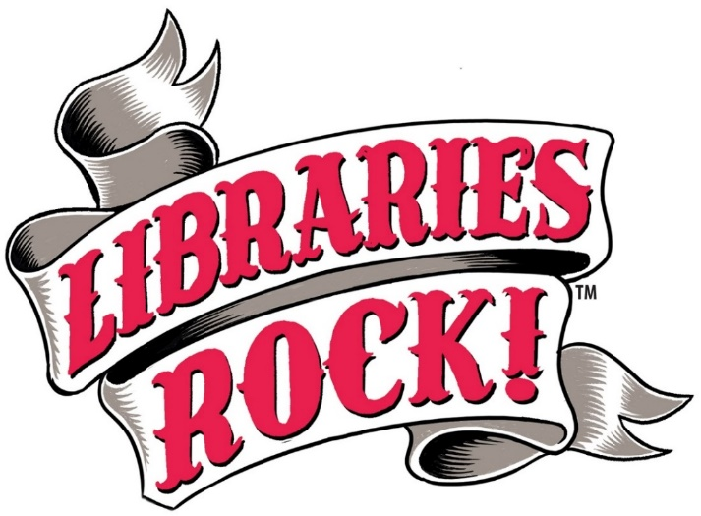

Tuesday mornings 10:00 – 10:45 a.m.
In the Contemporary Club (173 Eureka St., behind the library)
June 12 ~ Kick-Off with Twinkle Time (music & dancing show)
June 19 ~ Marionettes with Franklin Haynes “Marionette Magic”
June 26 ~ One World, One Rhythm (percussion & music show)
July 3 ~ David Cousin ~ (juggling show)
July 10 ~ Arty Loon ~ (magic & comedy)
July 17 ~ Michael Mezmer ~ (magic & illusion)
July 24 ~ Dino Encounters (life-size dinosaurs)
July 31 ~ Joseph Peck (Caribbean Drums show)

A.K. Smiley Public Library
125 W. Vine St.
Redlands, CA 92373
(909) 798-7674

